**CST-361 - Design Report Template**

|  |  |  |
| --- | --- | --- |
| **Topic:** | CLC – Project Milestone 2 | |
| **Date:** | *December 17, 2018* | |
| **Revision:** | *2.0* | |
| **Team:** | 1. *Fredrick Onduso Ondieki* | |
|  | |
|  | |
|  | |
| **Weekly Team Status Summary:** | |  |  |  |  | | --- | --- | --- | --- | | **User Story** | **Team**  **Member** | **Hours**  **Worked** | **Hours Remaining** | | Made update on the initial database design and development | Fredrick Ondieki | *1.0* |  | | Updated the application diagrams to include the shopping cart functionalities. | Fredrick Ondieki | 2.0 |  | | Updated the project goals to include the time spent on each milestone to use the:   * Agile Scrum Product Backlog * Agile Scrum Sprint Backlog * Agile Scrum Burn Down Chart | Fredrick Ondieki | 2.5 |  | | Worked on the Agile documents files (Spreadsheet) for the project activities. | Fredrick Ondieki | 1.0 |  | | Separated the project to have front and the back end. The Back end will involve the Administrator activities while the Front End will include the user interface activities such as:   * Creating user account * Login to the application * Searching for the Books | Fredrick Ondieki | 1.0 |  | | Drafted the Browsing image file which will be used for search and browsing functionality | Fredrick Ondieki | 1.0 |  | | Created user Interface wireframes | Fredrick Ondieki | 2.0 |  | | Created the UML deployment diagram for the project | Fredrick Ondieki | 1.0 |  | |  |  |  |  | | |
| **GIT URL:** | https://github.com/FREDDYSMALLZ/OnlineBookStore_CST-361 | |
| **Peer Review:** | *Y/N* | Yes. I acknowledge that I have reviewed this report and agreed to the approach that I will be taking. |

**Planning Documentation**

**Agile Scrum Product Backlog:**

https://github.com/FREDDYSMALLZ/OnlineBookStore_CST-361

**Agile Scrum Sprint Backlog:**

https://github.com/FREDDYSMALLZ/OnlineBookStore_CST-361

**Agile Scrum Burn Down Chart:**

https://github.com/FREDDYSMALLZ/OnlineBookStore_CST-361

**Agile Retrospective Results:**

*The following table should be completed after each Retrospective on Things That Went Well (Keep Doing). An alternative to the following table is to use a Mind Mapping tool such as Coggle. If you use a Mind Mapping tool you must include a URL or Image File.*

|  |
| --- |
| **What Went Well** |
| Successfully separated the project to include front and the back end. |
| Successfully completed the design documentation and included updated shopping cart image |
| Successfully started the initial database design for the user account creation and login functionalities. |

*The following table should be completed after each Retrospective on Things That Didn’t Go Well (Stop Doing) and What Would Be Done Differently Next Time with an Action Plan to Improve (Try Doing and Continuous Improvement). An alternative to the following table is to use a Mind Mapping tool such as Coggle. If you use a Mind Mapping tool, you must include a URL or Image File.*

|  |  |  |
| --- | --- | --- |
| **What Did Not Go Well** | **Action Plan** | **Due Date** |
| No enough data to create Agile Scrum Chart. | Enough data availability in later milestones will be able to create a Agile Scrum Burn Down Chart |  |
| No development code uploaded for the project. | Code will be uploaded on the next and later milestones. |  |
|  |  |  |

**Design Documentation**

This section will include the different designpattern used to develop the application. These diagrams include:

* UML Use case diagram
* UML Class diagram
* UML Component diagram
* UML Deployment diagram

**Other Diagrams**

**Class Diagrams:**

The class diagram bellow shows all the potential features of the application.



**Use Case diagram**

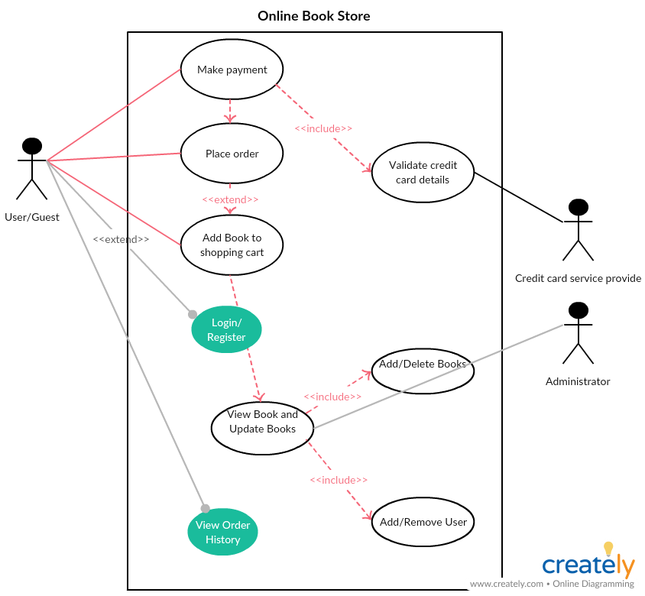

**Component diagram**

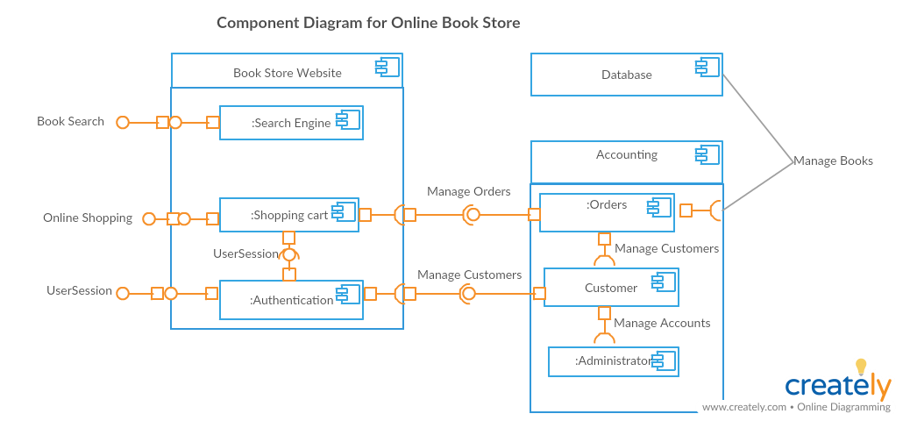

**Deployment Diagram**

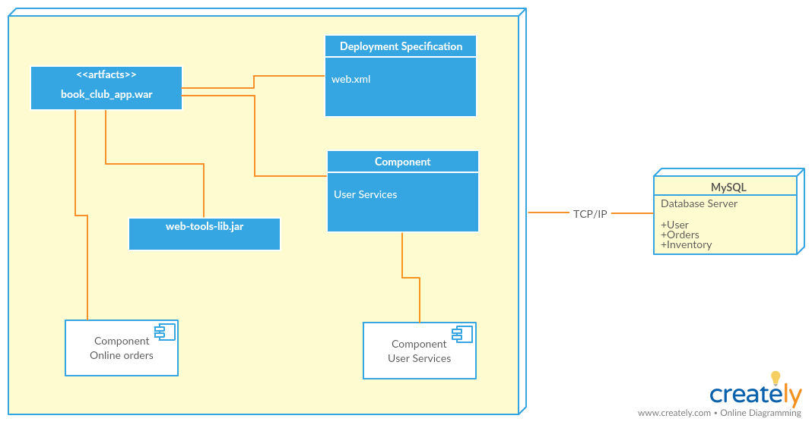

**Service API Design:**

This project intends to use the MySQL as a relational database, among other services APIs which will be included in later milestones. Also, the project intends to employ the MVC design and the façade project design pattern project.

**Security Design:**

This report outlines the security design that will be used in the store. First, the user will be required to register for account. Afterwards, the user name and password used will be used to authenticate and authorize the user to receive services from the online book store application. On the other hand, the administrator has all the privileges in controlling the application functionalities. One of the administrator roles is not limited to adding and removing users but also perform all CRUD functions for the books.

**Other Documentation:**

**User Interface Wireframes**

Used Balsamiq online tool for drawing the wireframes for the user to navigate through the application.

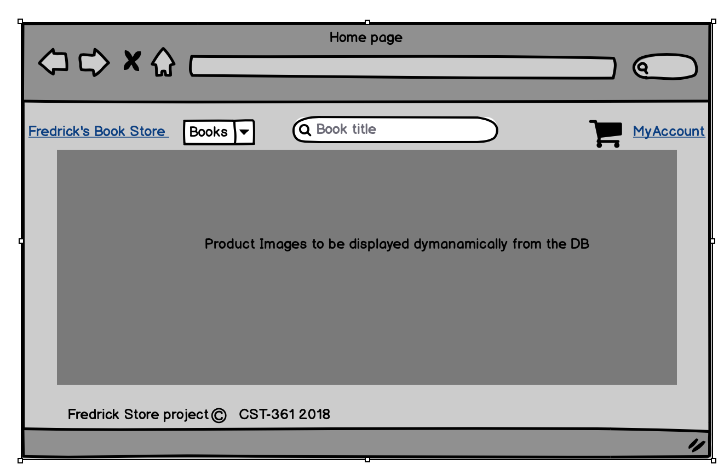Home page for the program application